KAMPALA JUNIOR ACADEMY
HOLIDAY WORK SET TWO 2020
ENGLISH
PRIMARY ONE

My name is ________________________________________________
Class ______________________________________________________

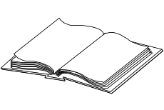
1. Name these objects.
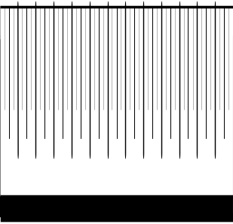
(a) ______________ (b) _____________
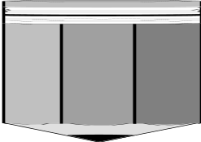
(c) _________________

2. Arrange in abc order.
(a) f c h g ____________________________
(b) d b c a ___________________________

3. Write the words using small letters.
(a) DOG ____________ (b) CLASS ____________

4. Fill in ‘an’ or ‘a’
(a) This is _____ apple.
(b) The baby is sitting on ______ mat.
(c) Look at _____ egg.

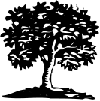
5. Write the words correctly.

(a) top _______ (b) erte _________
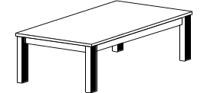
(c) balet __________

6. Answer correctly
(a) This is a book. These are __________

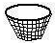
(b) This is a basket. These are __________

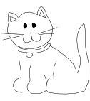
(c) This is a kitten. These are __________

7. Circle the noun.
- I have a ball.
- Tom is playing.
- She lives at Kampala.

8. Use ‘has’ or ‘have’
(a) She _______ a nice bag.
(b) We ________ got mangoes.
(c) The big tree ________ fallen.

9. Join the two words to form one word.
(a) ink + pot = _____________________
(b) bed + room = __________________
(c) ball + pen = ___________________
(d) black + board = ________________
(e) match + box = ________________

10. Fill in the gap with in, on, under, near

(a) The cup is ________ the table.

(b) The box is _______ the pot.

(c) The stick is _______ the tin.
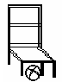
- The ball is _________ the chair.

11. Fill in ‘was’ or ‘were’
(a) The boys __________ dancing in the hall.
(b) He ___________ late for school.
(c) Jesca and Agnes ______________ running to church.
(d) James ___________ smart yesterday.
12. Make three sentences from the table.
He  The girls  Daddy | is  are | driving a car  eating food  playing

- _______________________________________________
- _______________________________________________
- _______________________________________________

13. Match the opposites
(a) big bad
(b) poor thin
(c) fat small
(d) good rich

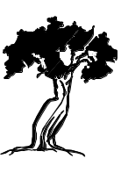
14. Write what is happening in the picture.
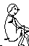
(a) Tom is ________________ a tree.
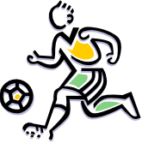
(b) Ronald is __________________ a ball.
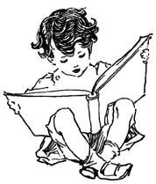
(c) Sandra is _________________ a book.

15. Write a small word from a big word.
(a) headmaster _____________
(b) handbag _______________

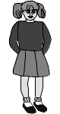
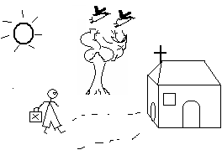16. Name the given pictures to complete the story.
Monica is a school ____________. She goes to

____________ every Sunday. One day when she was

playing net _____________, she kicked her toe on a __________.
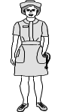
She was taken to the school ____________for treatment.

Her teacher told her to be careful.

END

